Project Proposal Template
Agentic AI Course (B24EAS601)

Team Number:
Team Member Name (s):

Proposed Project Title:

1. Problem Statement & Use Case: Your problem statement should answer the following questions clearly:
- What real-world problem are you solving?

- Who is the target user / beneficiary?

- What currently happens (manual process, existing tools, pain points)?

- Why is this a good fit for an agentic AI solution (vs a simple LLM prompt / RAG chatbot?)

For example, below are some good problem statements and use cases:
- “Freelancers spend 4–8 hours/week chasing late invoice payments and reconciling partial payments. Existing tools (QuickBooks, FreshBooks) send reminders but don’t negotiate, follow-up intelligently, or escalate based on client history.”
- “Researchers waste hours finding, reading, and synthesizing recent papers on niche topics. Current tools (Elicit, Research Rabbit) help discovery but don’t produce structured literature reviews with critical analysis.”

2. Justify that your application is Agentic?
Explain why your application needs autonomy, iteration, tools, planning, reflection, and/or multi-agent collaboration
Answer the following:
- Which core agentic capabilities are essential for your app? (tool use, reflection / self-correction, planning & decomposition, multi-agent coordination)
- What would fail (or be very weak) if you built this as a single LLM call or basic chain?
- Expected agentic behavior examples (e.g. “The agent should notice inconsistent data from two sources, reflect, and re-query with better phrasing.”)

3. High-Level Solution Overview
Describe your intended agentic architecture in plain English + simple diagram.
Include:
- Main agent(s) and their roles (e.g. Researcher, Critic, Writer, Coordinator)
- Key agentic patterns you plan to use:
  - Reflection / self-critique loop
  - Tool use (which tools? search, code exec, APIs, DB…)
  - Planning (plan-and-execute, hierarchical, ReAct-style)
  - Multi-agent (CrewAI style roles / supervisor, LangGraph multi-actor)
- Memory strategy (conversation memory, vector store for long-term recall, entity memory…)
- High-level flow (e.g. User query → Planner decomposes → Agents execute in parallel → Supervisor synthesizes → Reflection checks → Output)
Mandatory: Include at least one simple block diagram / flowchart (tools: draw.io, Excalidraw, Lucidchart, Mermaid in Markdown, even hand-drawn photo)
Here is an example diagram:

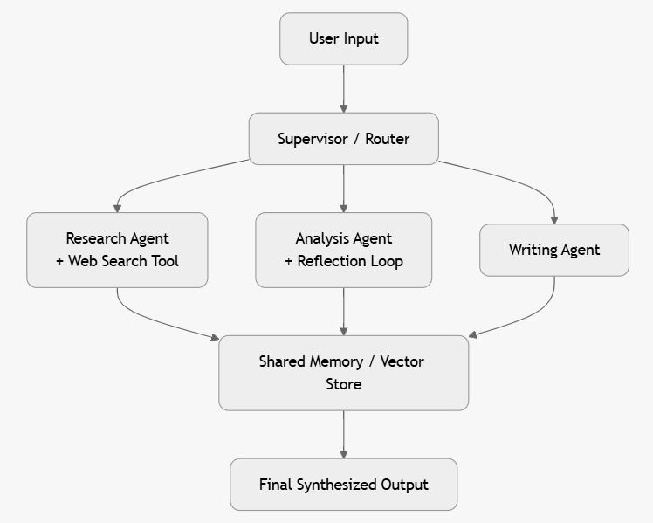

4. Proposed Technology Stack
Include following information about your app:
- LLM provider(s) & model(s) you plan to use (and why)
- Core framework (LangGraph, CrewAI, AutoGen, LlamaIndex + custom…)
- Tools you plan to build / use (Tavily, Wikipedia, code interpreter, custom APIs…)
- Vector DB / memory (Chroma, Pinecone, simple list…)
- Frontend / delivery (Gradio, Streamlit, FastAPI, CLI only…)
- Evaluation tools (LangSmith, manual rubric, custom metrics…)
- Deployment target (Hugging Face, Render, Vercel…)

5. Success Metrics & Evaluation Plan (≈ ½ page)
How will you know that your app works well? Be specific.
- Quantitative metrics you will track (examples):
  - Task success rate (% of test cases completed correctly without human help)
  - End-to-end latency
  - Tool-call accuracy / efficiency
  - Cost per task (tokens / $)
- Qualitative / human eval (examples):
  - Rubric scores on output quality (accuracy, completeness, coherence)
  - User satisfaction (you can run a mini user study with 5–10 people)
- Number of test cases you plan (aim ≥ 15–30 by final demo)
- Failure modes you anticipate & how you’ll measure them

6. Risks, Challenges & Mitigation Plan
List 3–6 realistic risks and how you plan to address them.
Examples:
- Hallucinations on factual queries → reflection loop + source citation + cross-verification
- Infinite loops / high cost → strict token limits, max iterations, cost monitoring
- Tool failures (API down) → fallback prompts, error handling nodes in LangGraph
- Scope creep → strict MVP definition (core loop working first)

7. Timeline & Milestones
Map to course schedule:
- By Mar 25 (Demo 1): Single-agent prototype with tool use + basic reflection
- By Apr 10 (Document 2): Detailed architecture, multi-agent design, early eval results
- By Apr 22 (Demo 2): Multi-agent MVP, evaluation dashboard, deployed UI
- By May 5 (Final): Polished, reliable, evaluated product + presentation
Week-by-week mini work plan (3–5 bullets) is fine.

